**MST 1102- Introduction to Statistics WkSheet 7**

**(Last Name, First Name): ______________________________________________________________**

**Measures of: Central Tendency and Dispersion II**

1. On examining the scores in a test, it was found that there is a higher frequency of low scores and a lower frequency of high scores.
2. If a histogram is to be constructed for these scores, will it be positively skewed or negatively skewed? **[1 mark]**

**__________________________________________________________________________________________________________________________________**

1. Explain where you expect to find the three measures of central tendency. **[3 marks]**

**________________________________________________________________________________________________________________________________________________________________________________________________________________________________________________________________________________________________________________________________________________________________________________________________________________________________________________________________________________________________________________________________________**



1. The histogram displays the age of people watching a comedy movie at a cinema.
2. What is the shape of the distribution? **[1 mark]**

______________________________________________________________________________

1. What is the relationship between the three measures of central tendency (mean, mode, median)? **[1 mark]**

**______________________________________________________________________________**

1. Describe the distribution in terms of the frequency of ages.**[2 marks]**

**_______________________________________________________________________________**

________________________________________________________________________________

___________________________________________________________________________________________________________________________________

1. A researcher is comparing two multiple-choice tests with different conditions. In the first test, a typical multiple-choice test is administered. In the second test, alternative choices (i.e. incorrect answers) are randomly assigned to test takers. The results from the two tests are:

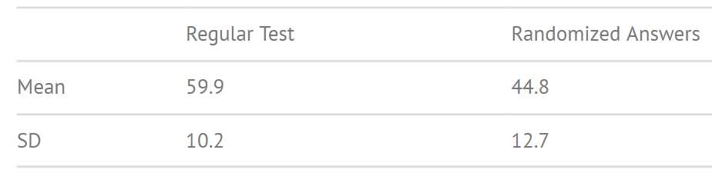Calculate the coefficient of variation for both conditions and interpret the results. **[3 marks]**

1. 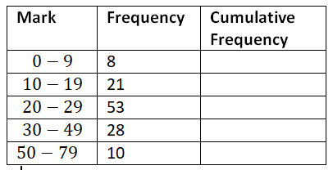The grouped frequency distribution below shows the examination marks for a group of 120 second year statistics students.
2. State one disadvantage of presenting the data using a grouped frequency distribution. **[1 mark]** ________________________________________________________________________ ________________________________________________________________________
3. Complete column 3 of the table. **[1 mark]**
4. Identify the median class. ______________________________ **[1 mark]**
5. Given that $L_{m}$ is the lower class boundary of the median class, state the value of $L_{m}$. ______________________________ **[1 mark]**
6. Given that $F_{m-1}$ is the cumulative frequency of the class before the median class, state $F_{m-1}$. ___________ **[1 mark]**
7. Given that $f_{m}$ is the frequency of the median class, state $f_{m}.$_____________________ **[1 mark]**
8. Given that $W_{m}$ is the width of the median class, state $W_{m}$. ______________________ **[1 mark]**
9. Hence, use the formula below to calculate the estimated median and interpret this value. **[3 marks]**

$$estimated median=L_{m}+\left(\frac{\left(\frac{n}{2}\right)-F_{m-1}}{f_{m}}\right)× W_{m}$$

______________________________________________________________________________________________________________________________________________________________________________________________________________________________________________________________________________

1. Find an estimate of the standard deviation for the data in the grouped frequency table above. **[4 marks]**
2. 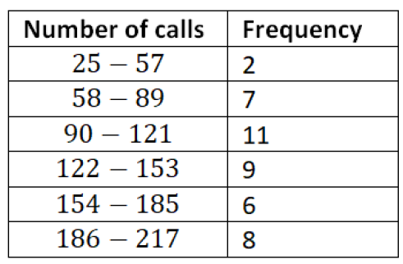The number of calls from motorists per day for roadside service was recorded for the month of December 2003. The results were placed in a grouped frequency table as seen below.
3. Identify the modal class: ___________________ **[1 mark]**
4. Identify the median class: __________________ **[1 mark]**
5. Given that $l_{m}$ represents the lower class boundary of the modal class, state $l_{m}$: _____________________ **[1 mark]**
6. Given that $f_{m}$ represents the frequency of the modal class, state $f_{m}$: ________________ **[1 mark]**
7. Given that $f_{m-1}$ represents the frequency of the class preceding the modal class, state $f_{m-1}$: _____________ **[1 mark]**
8. Given that $f_{m+1}$ represents the frequency of the class succeeding the modal class, state $f_{m+1}$: ____________ **[1 mark]**
9. Given that 𝑤𝑚 represents the width of the modal class, calculate $w_{m}$: ___________________ **[1 mark]**
10. Hence, use the formula to calculate the estimated mode and interpret this value: **[3 marks]**

$$estimated mode=lm+\left(\frac{f_{m}-f_{m-1}}{\left(f_{m}-f_{m-1}\right)+\left(f_{m}-f_{m+1}\right)}\right)× w_{m}$$

______________________________________________________________________________________________________________________________________________________________________________________________________________________________________________________________________________

**Total: 35 marks**